**Problem Statement & Project Description**

This project device aims to measure the temperature of a person accurately regardless of the distance of the person to the device.  
As we know, if the person is not near to the device, the temperature reading might not be accurate. So, we are taking both the distance and temperature readings and we applied a mathematical function with a reference temperature to get the real and accurate reading of the temperature. The reference temperature is getting from the person that has the nearest distance to the device.   
  
The main components of the project:  
Temperature sensor (mlx90614)  
Ultrasonic sensor (HC-SR04)  
NodeMCU esp32  
ID card (Magnetic card)

The progress of the project is as follows: The person must show his ID card to the device so the device will take his temperature and also will record the distance between the person and the device. Lastly, the data will be sent to a web server.

The use case specification is shown below and it gives better understanding of the project.

|  |  |
| --- | --- |
| Use case ID | UC1 |
| Use Case Name | Temperature reading |
| Description | The user’s temperature and the distance between the user and the sensor will be recorded and save them in a web server |
| Actor | Residents, Students, Employees |
| Pre-Conditions | User must be identified using an ID card |
| Flow of events | Main flow:   1. User scans his ID card. 2. System measures the temperature and distance parameters. 3. System sends the date to a web server. 4. System compares the data according to the reference data (which is the data recorded when the user has the smallest value of distance). 5. System gives the accuracy of the values reading.   Alternative flow:   1. Invalid ID card: system shows an error message. |

**System Architecture**

****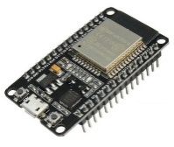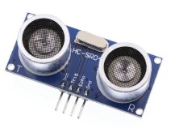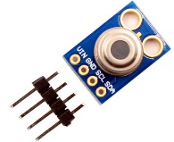

Shows the accuracy

Data & Analysis

Cloud Platform

Dashboard

HTTP

HC-SR04

Esp32

mlx90614

Sensors/Devices